4a)

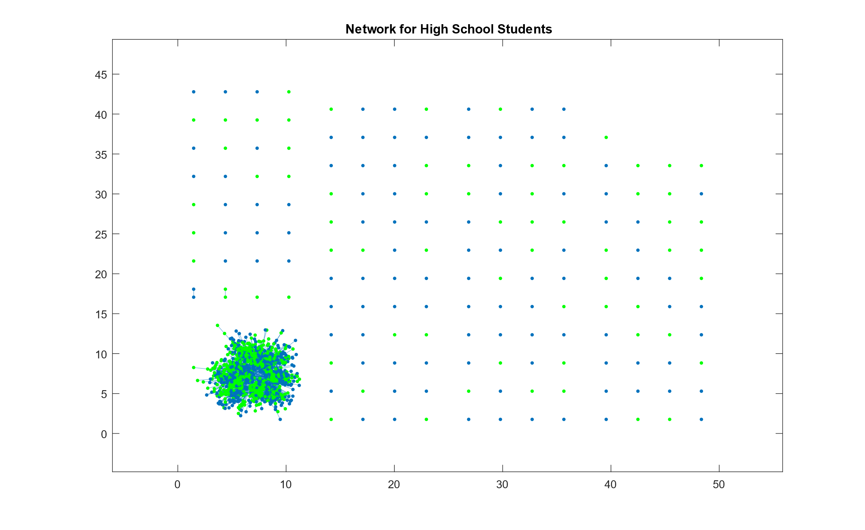

*Figure 1: Network for High School Students (Full)*

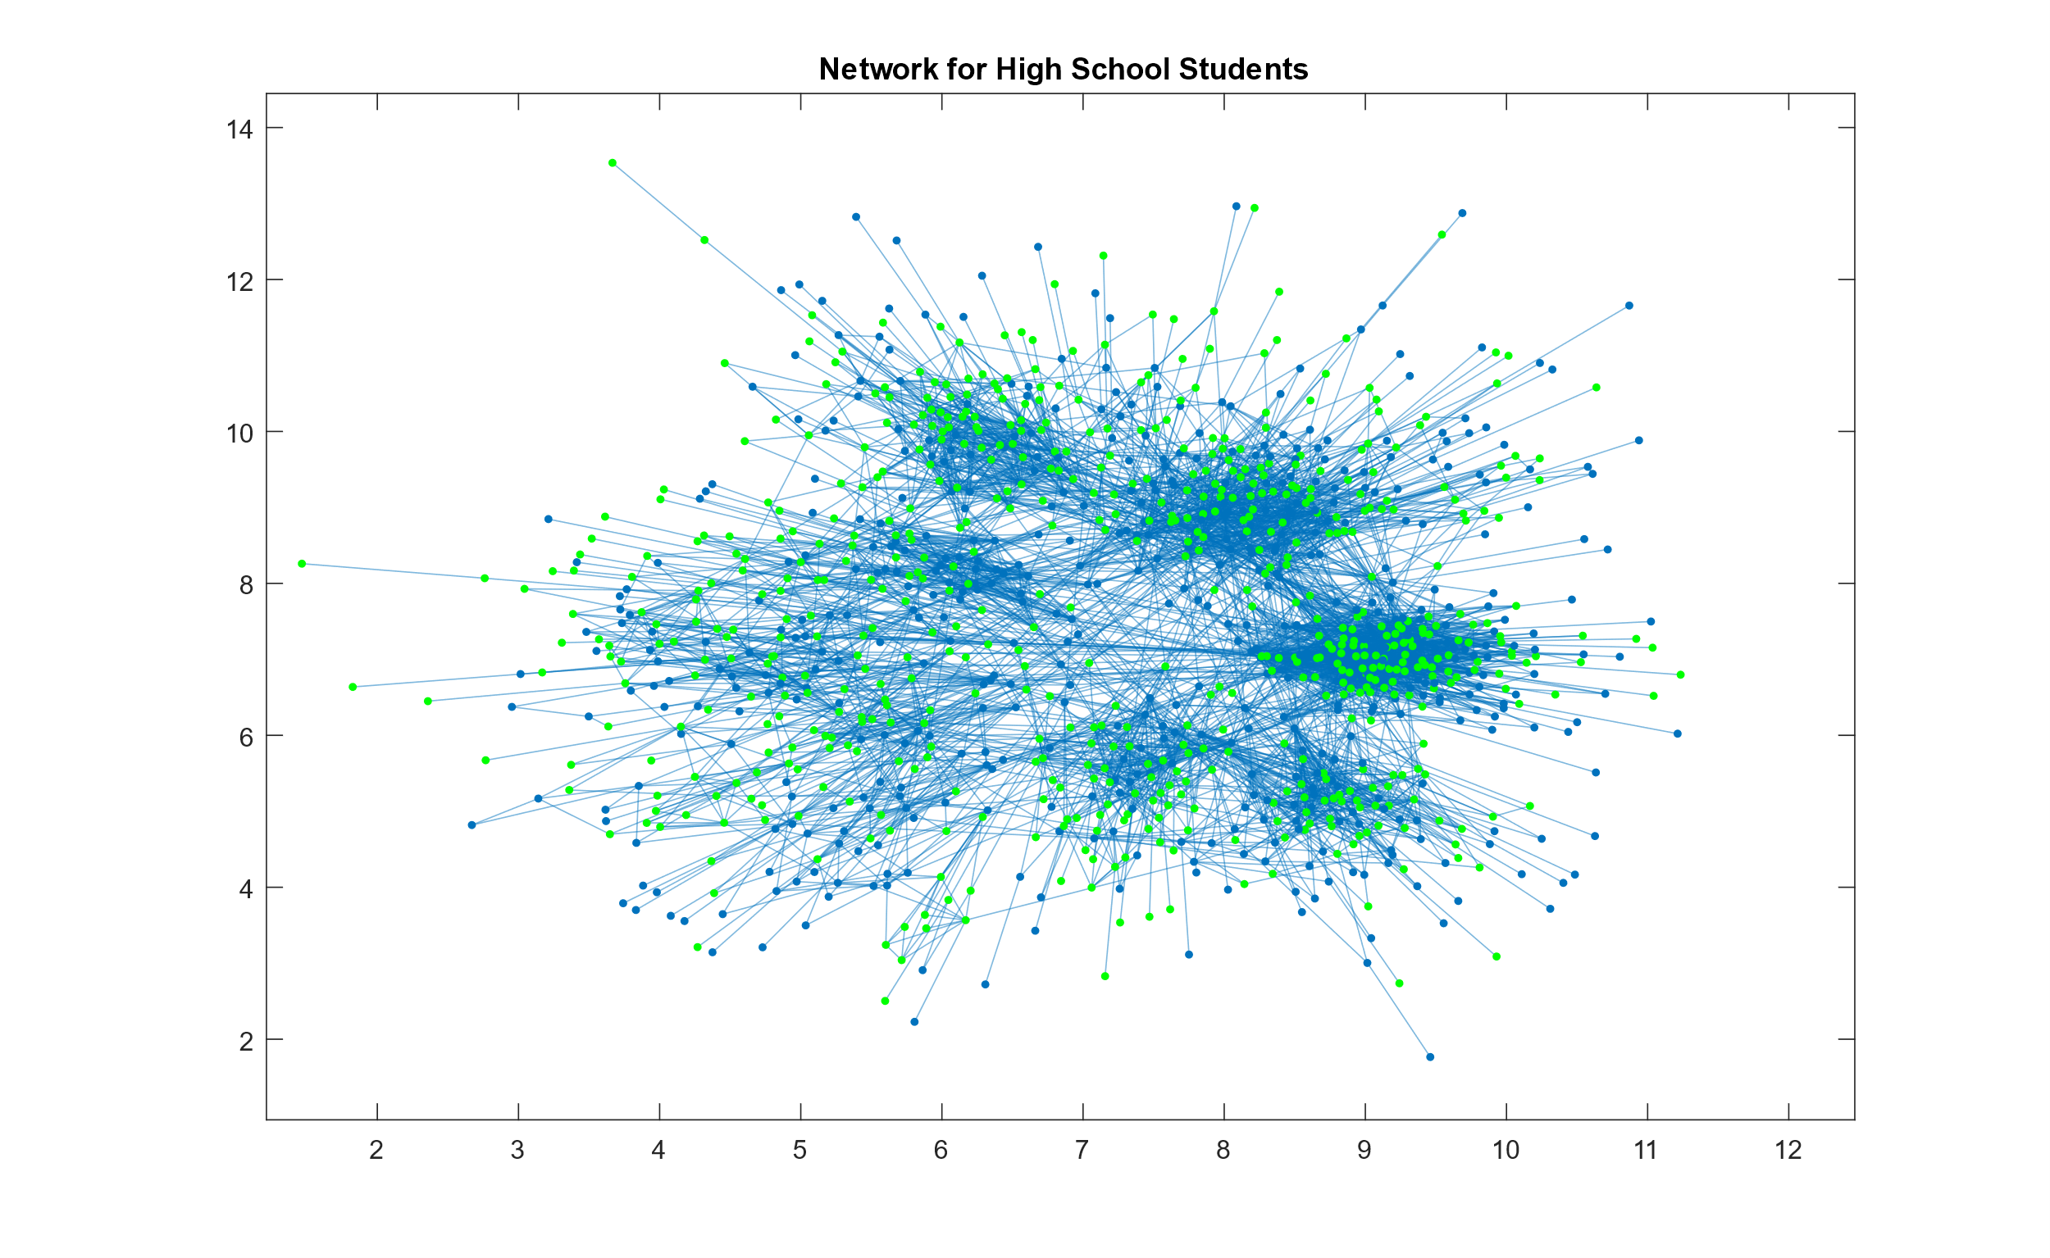

*Figure 2: Network for High School Students (Dense Cluster)*

4b)

Number of paths of length 2: 91590

Number of closed triangles: 5960

4c)

Cluster Coefficient: 0.2212

4d)

Cluster coefficient for this network is relatively low at 0.2212. This is likely due to the separation of friend groups at high school. While people may be acquainted with one another, they are not required to hold a friendship/friend group with one another, and as such there is a low cluster coefficient.

4e)

Probability of a link between a high and low performing student: 0.4992

4f)

Actual fraction for link between a high and low performing student: 0.3985

As such, students are more likely to form friendships among their similarly performing peers. This confirms the idea of homophily as the actual probability 0.3985 is much lower than the predicted probability of 0.4992.

5a)

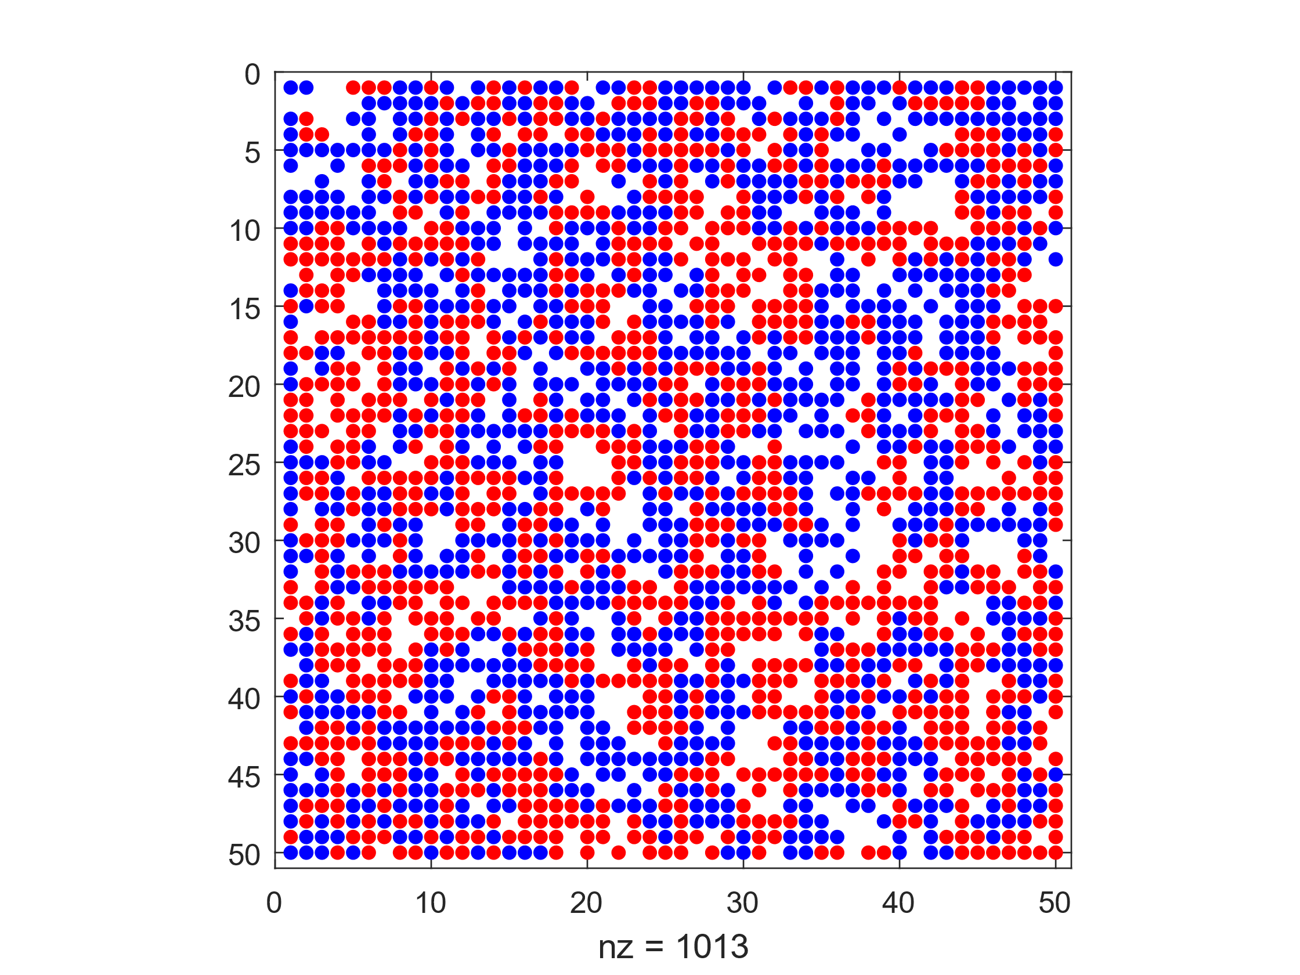

*Figure 3: Empty Ratio = 0.2, Similarity Threshold = 0.2*

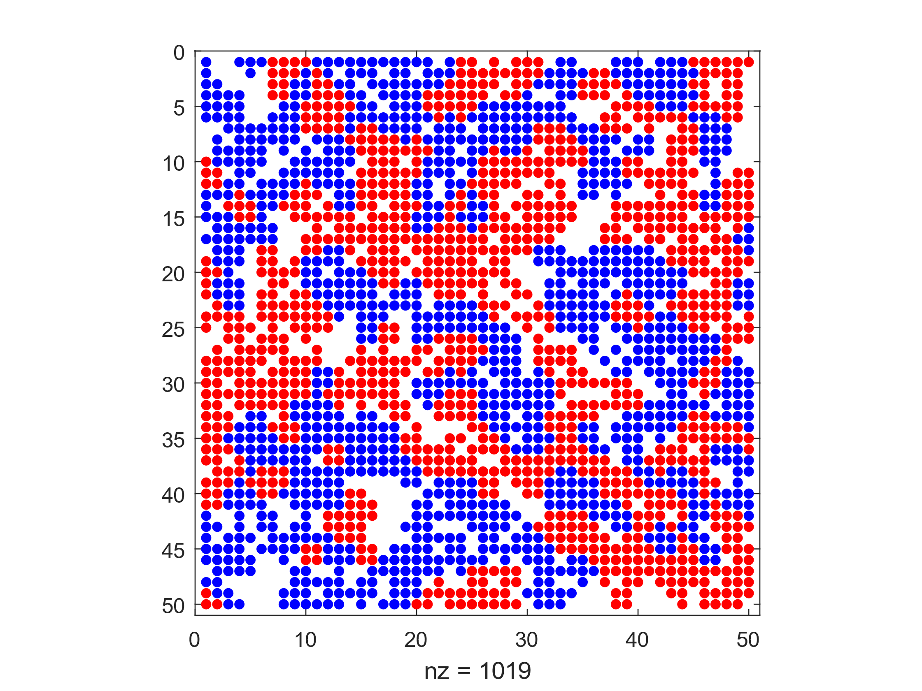

*Figure 4: Empty Ratio = 0.2, Similarity Threshold = 0.3*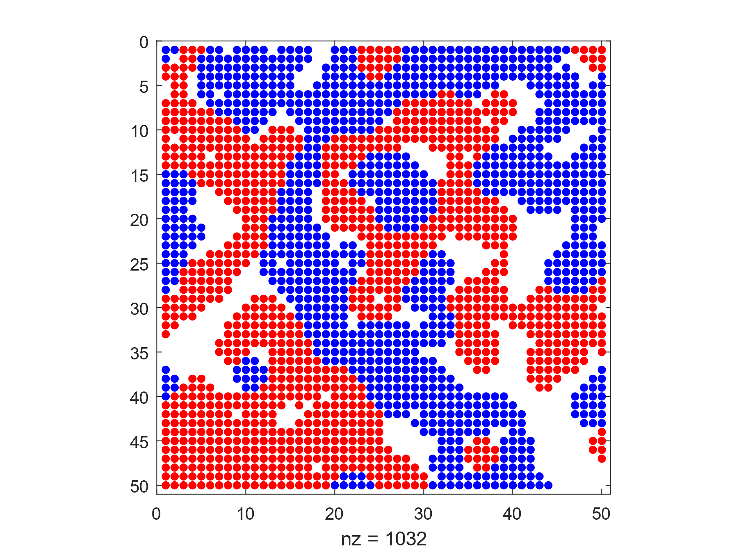

*Figure 5: Empty Ratio = 0.2, Similarity Threshold = 0.4*

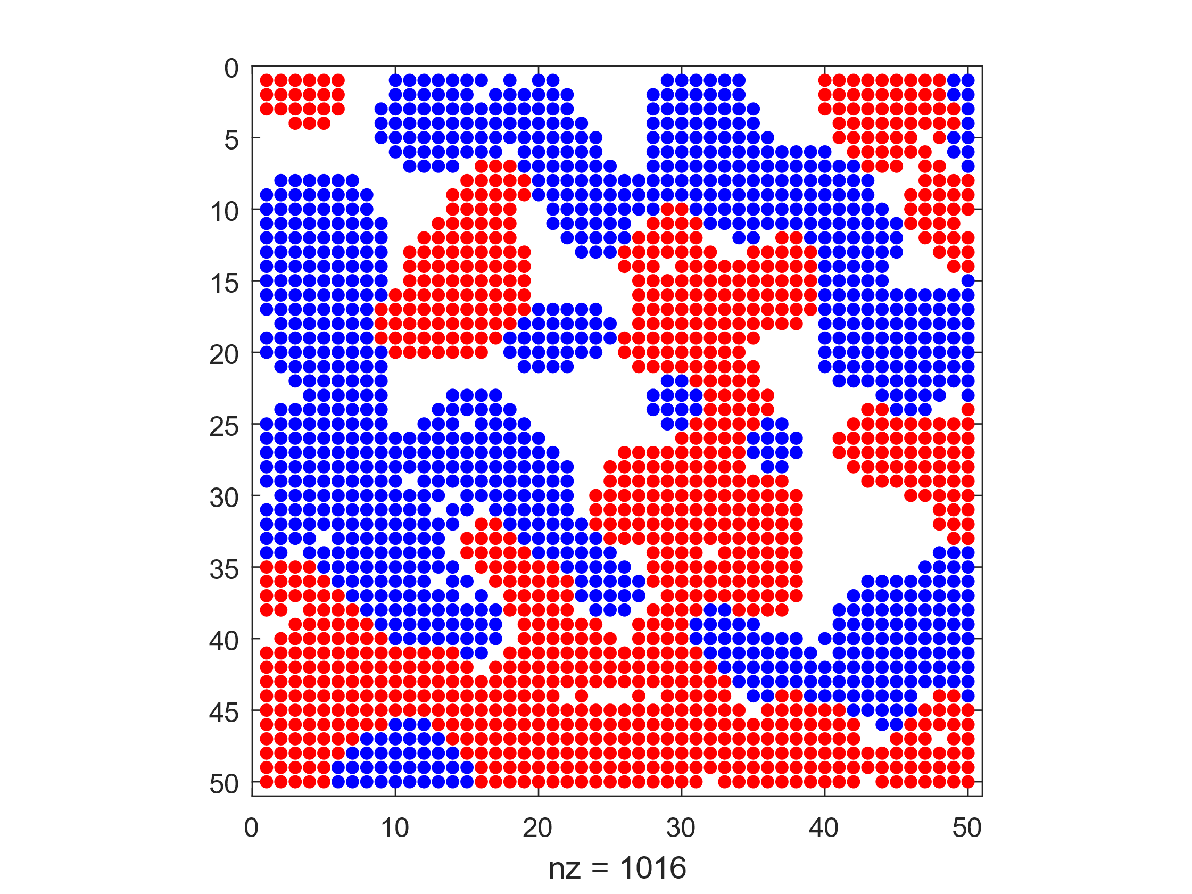

*Figure 6: Empty Ratio = 0.2, Similarity Threshold = 0.5*

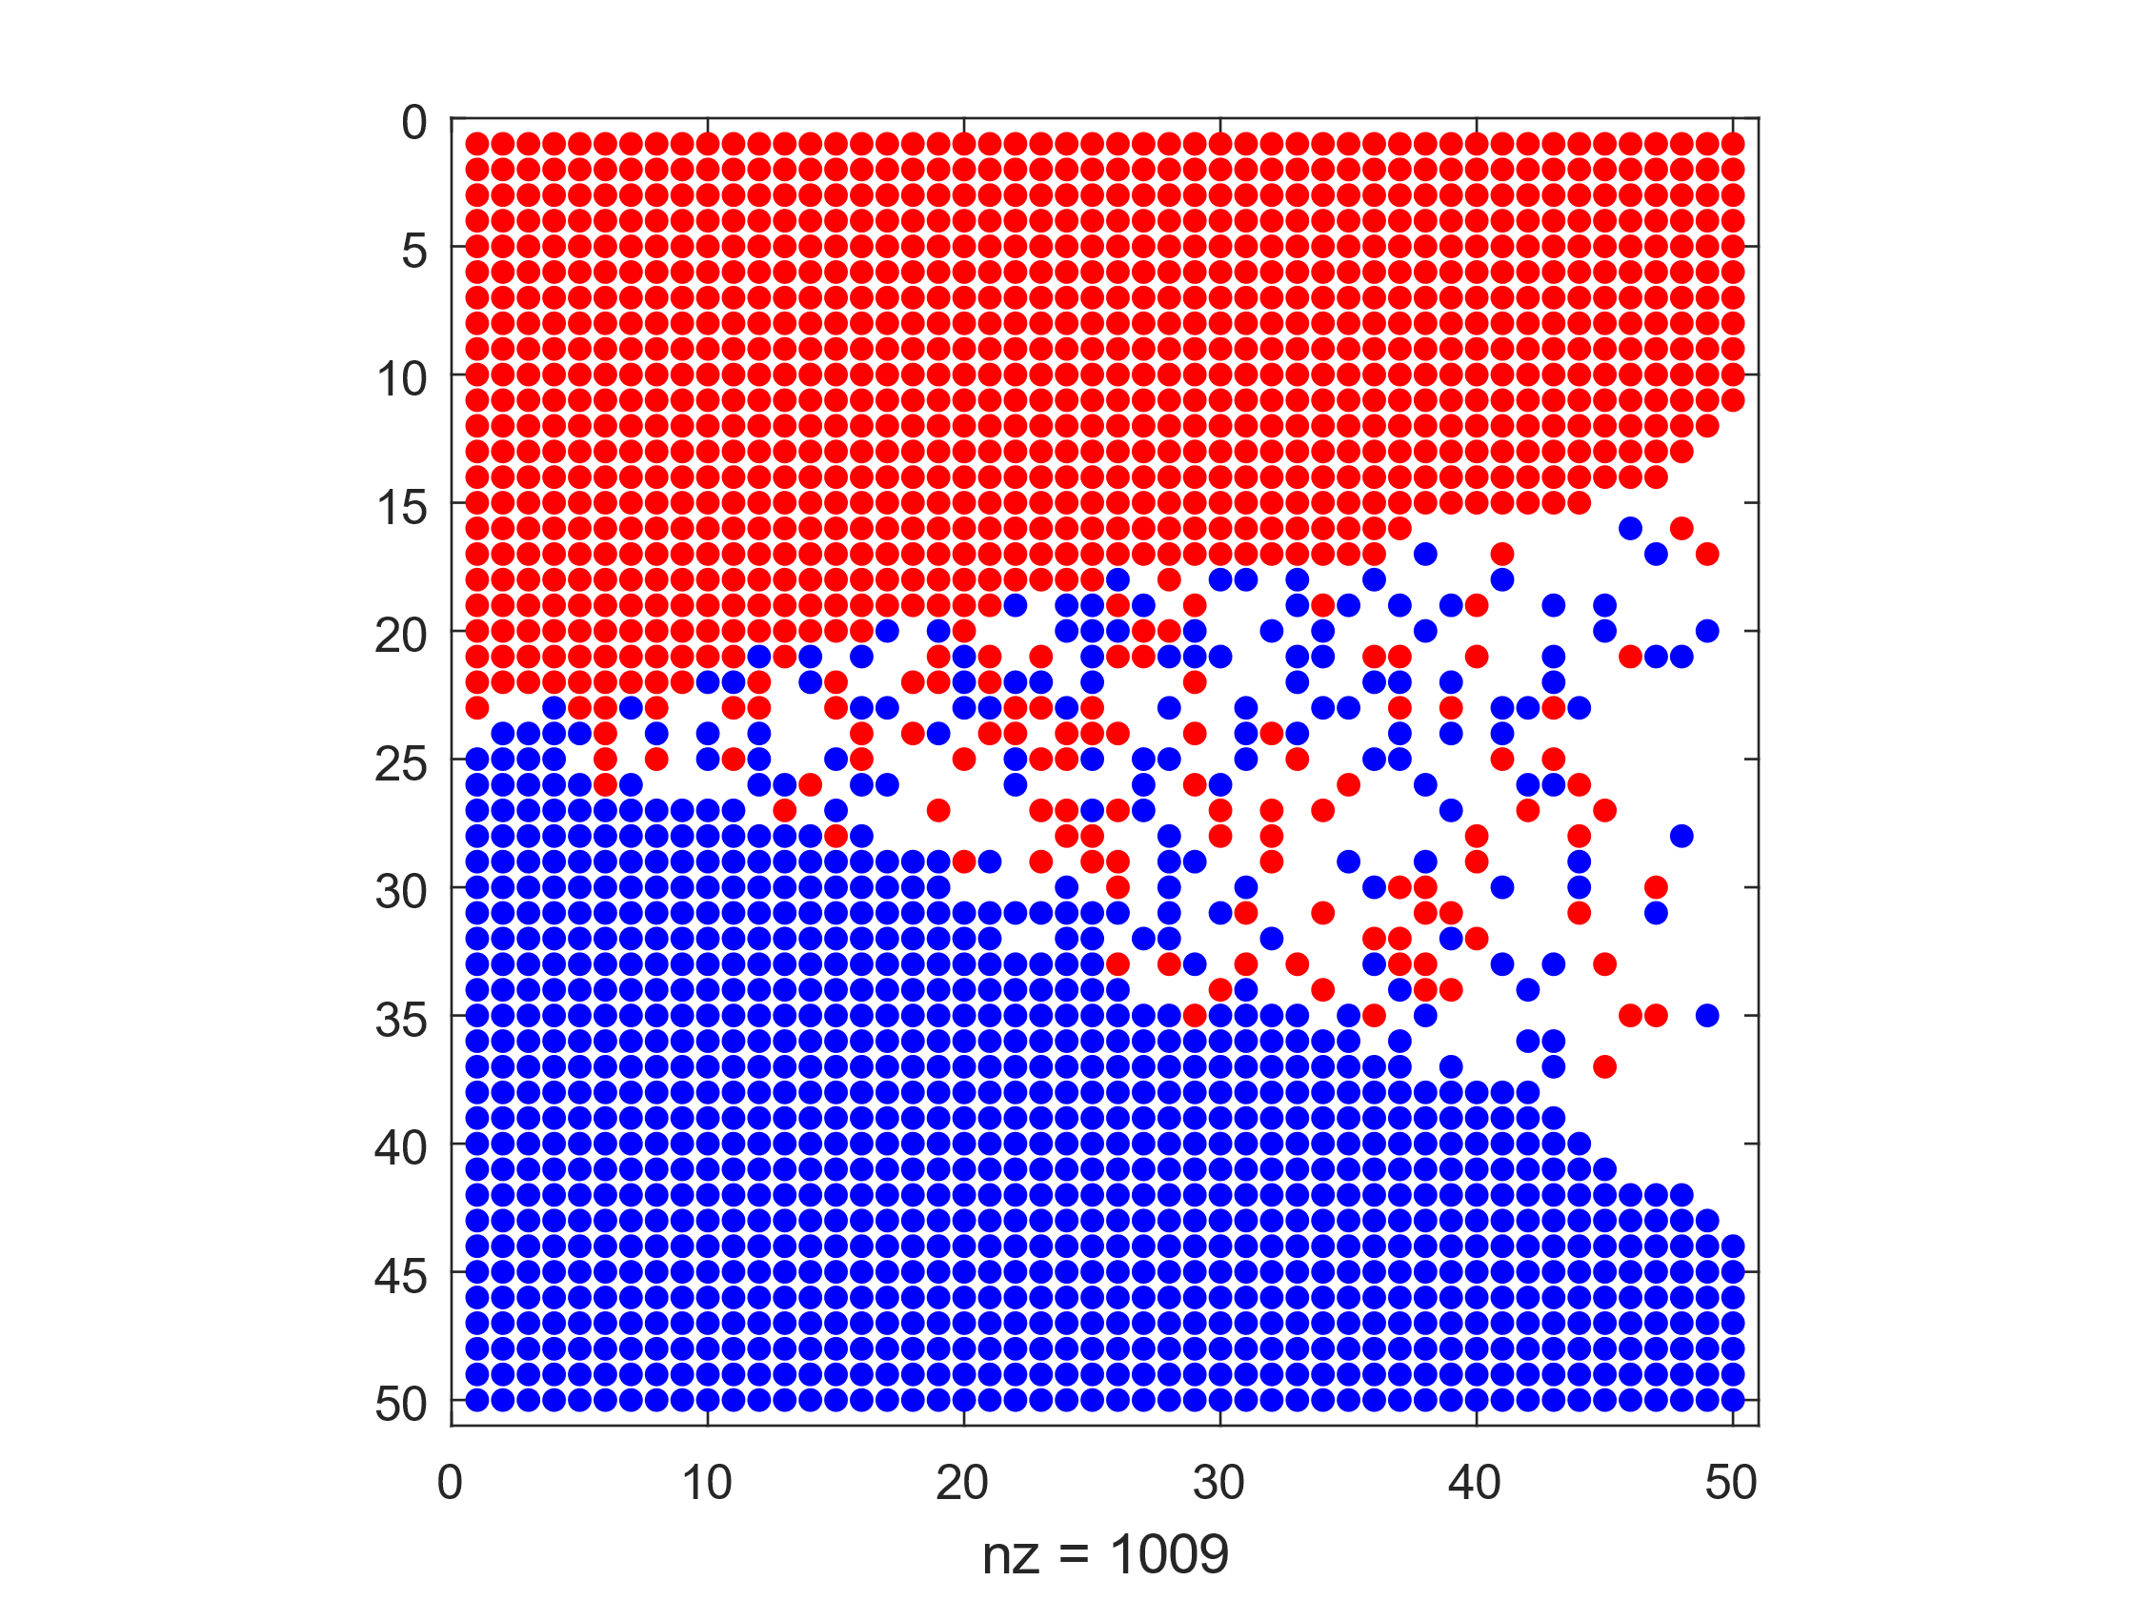

*Figure 7: Empty Ratio = 0.2, Similarity Threshold = 0.6*

The Schelling object converges more quickly when the similarity threshold is lower. This makes sense as when the similarity threshold is lower, the agent is more likely to settle in a position with fewer similar agents surrounding. However, as the similarity threshold increases, the agent will move constantly until it finds a position in which it is surrounded by similar agents. As such the model with a similarity threshold of 0.6 did not converge as there were agents in the centre who were not able to reach the similarity threshold regarding neighbours.

5b)

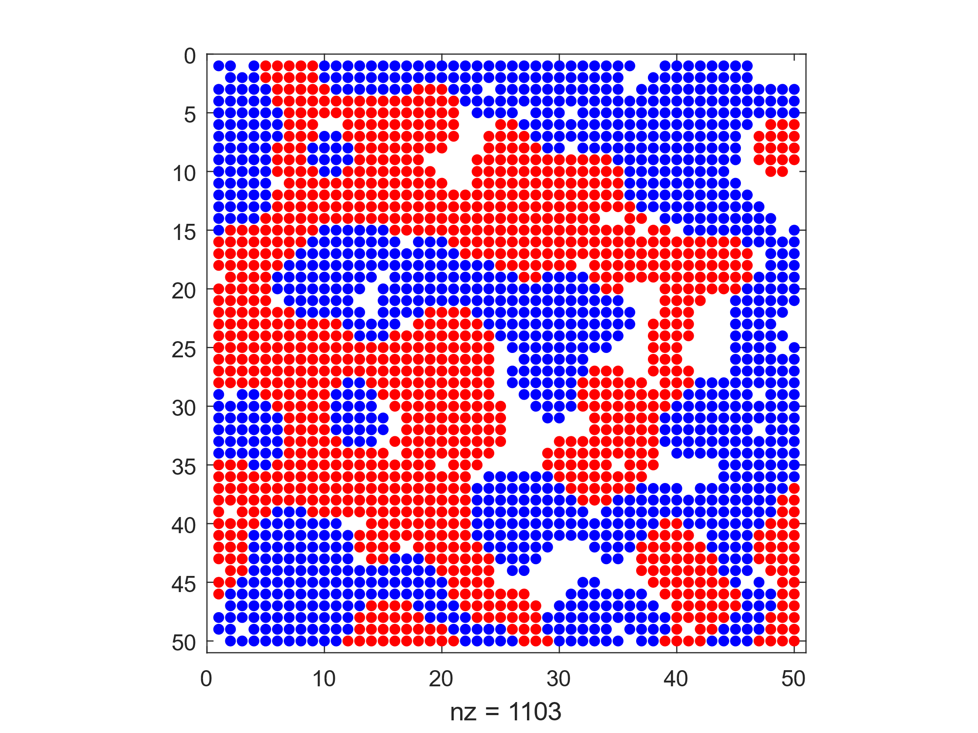

*Figure 8: Empty Ratio = 0.1, Similarity Threshold = 0.4*

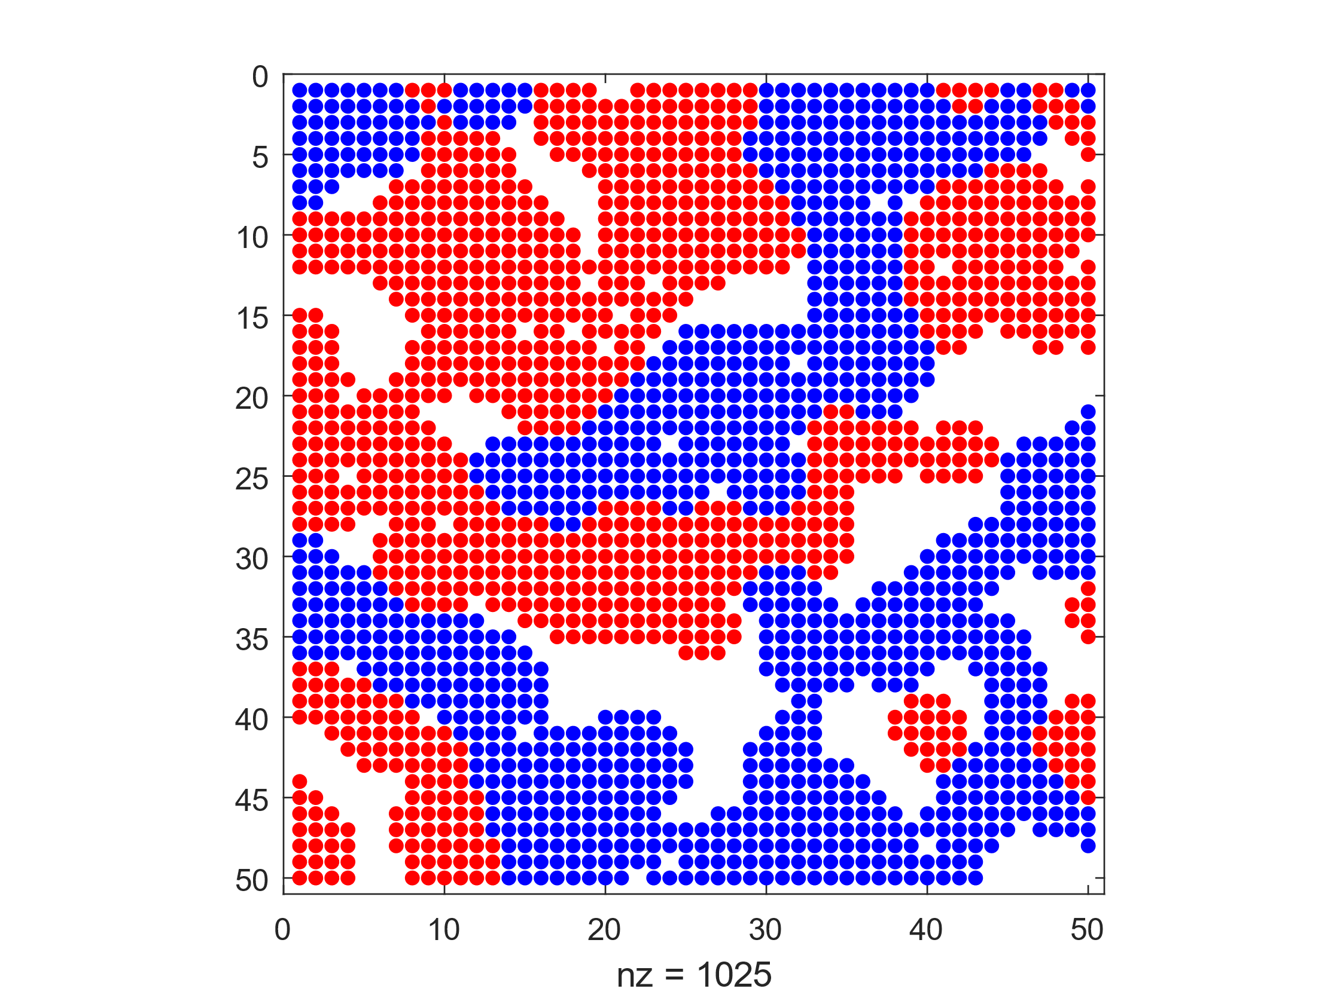

*Figure 9: Empty Ratio = 0.2, Similarity Threshold = 0.4*

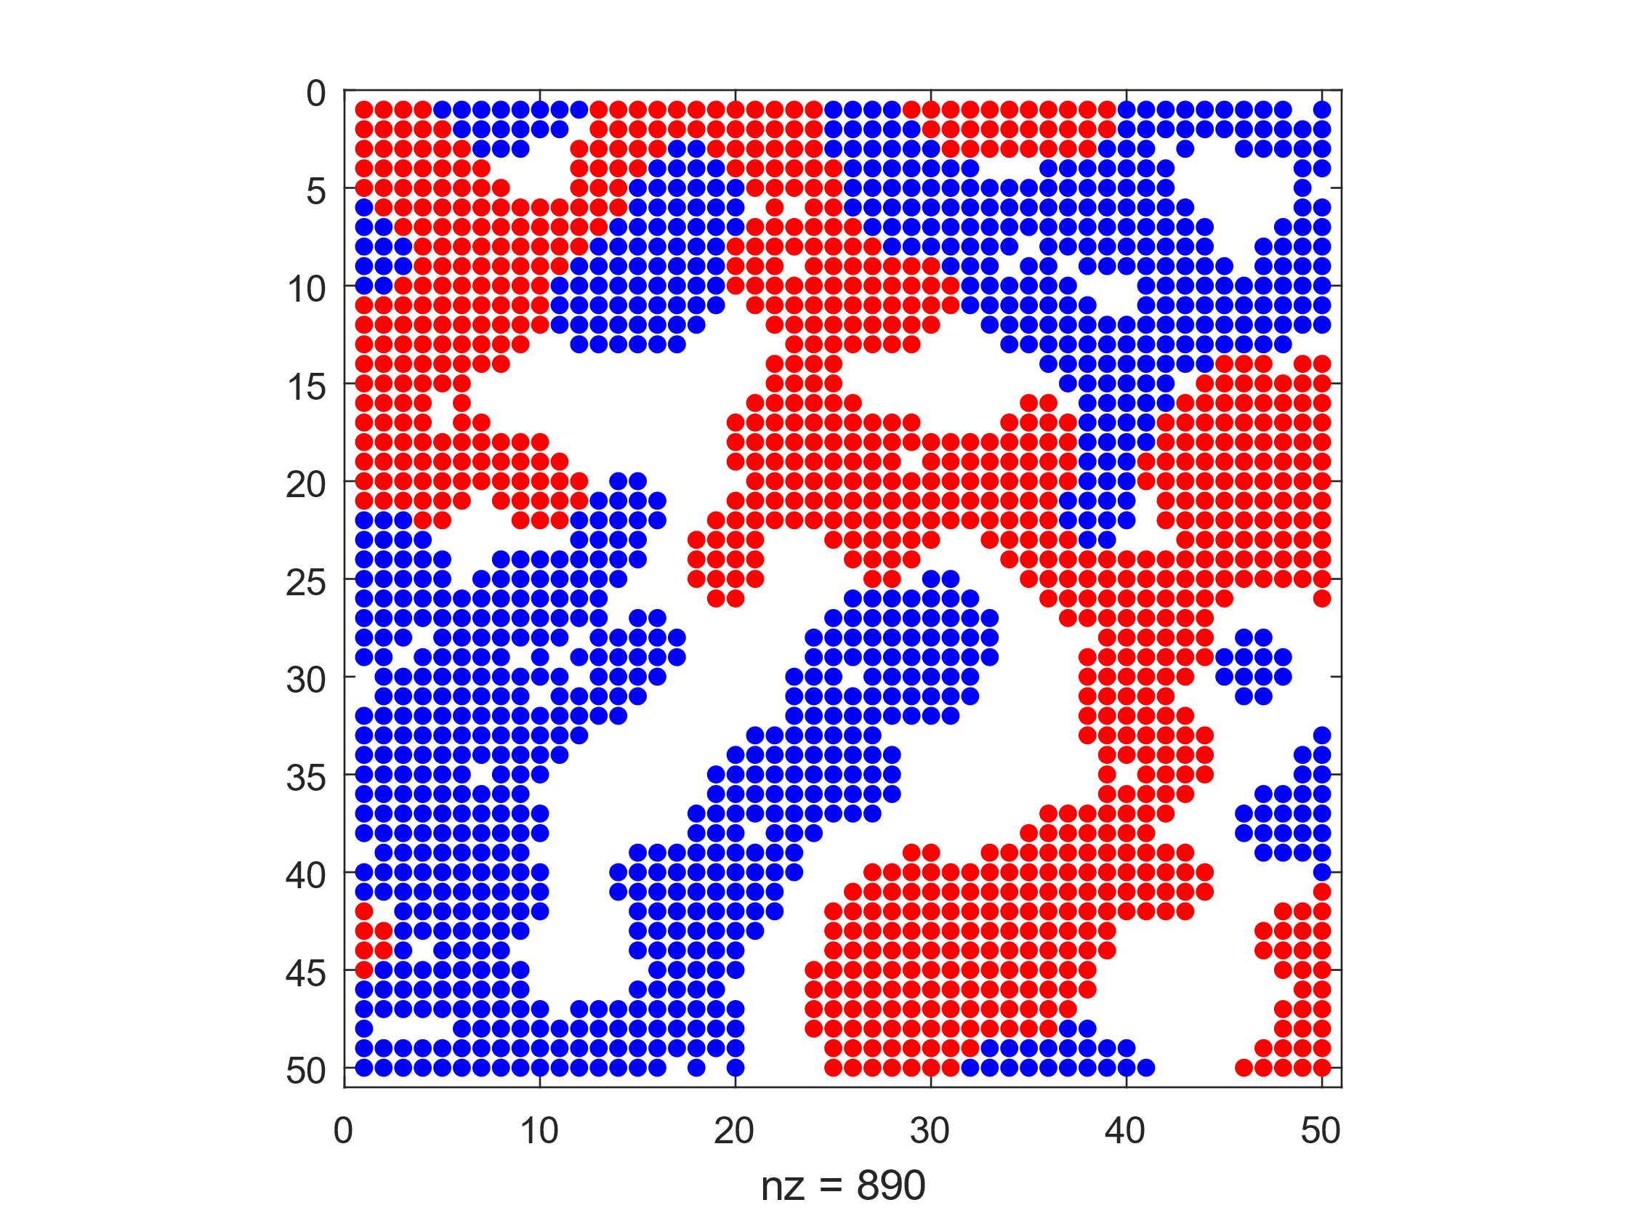

*Figure 10: Empty Ratio = 0.3, Similarity Threshold = 0.4*

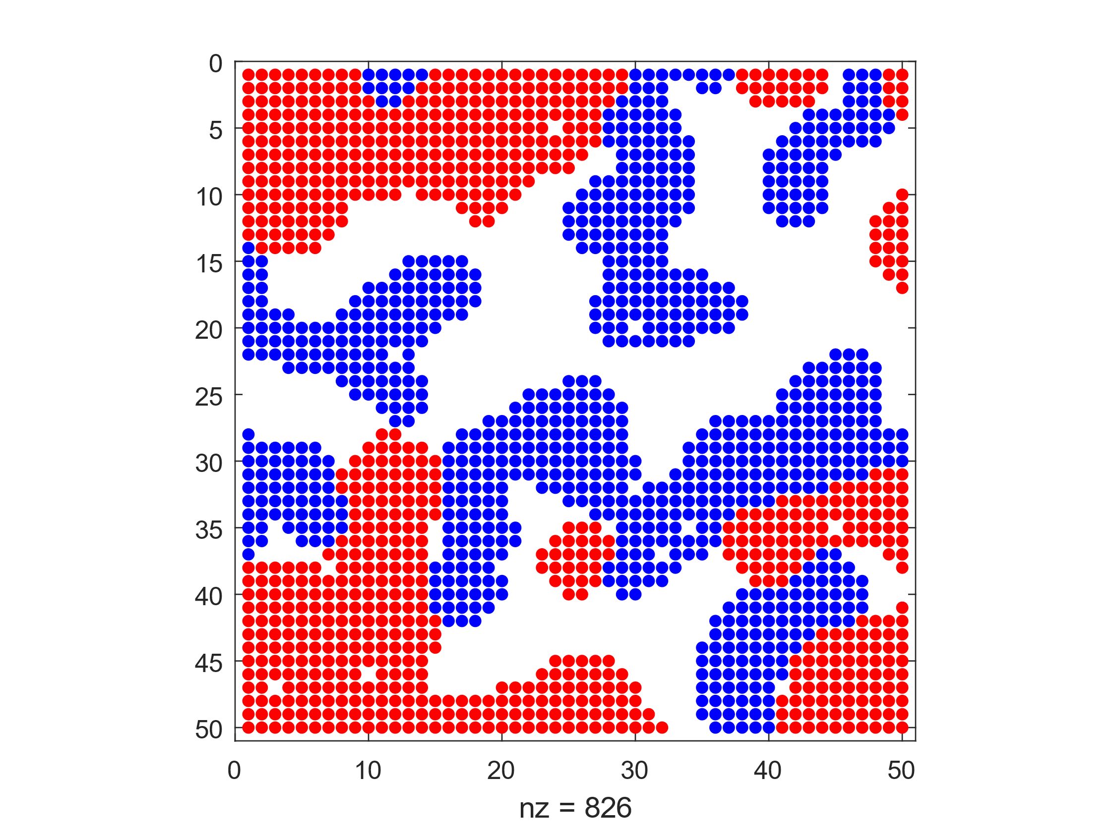

*Figure 11: Empty Ratio = 0.4, Similarity Threshold = 0.4*

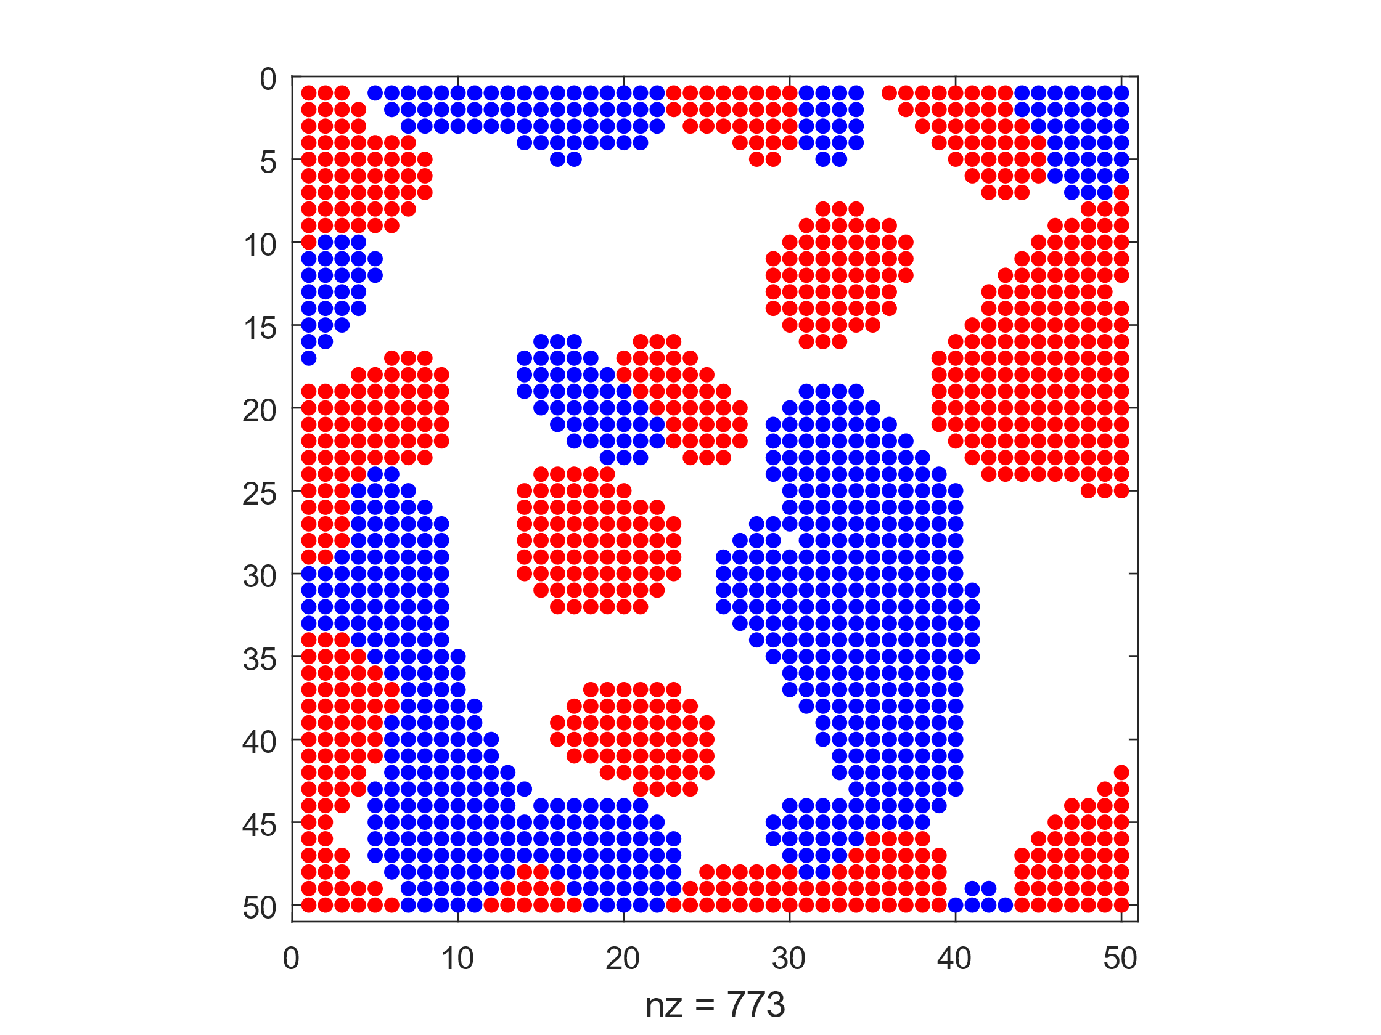

*Figure 12: Empty Ratio = 0.5, Similarity Threshold = 0.4*

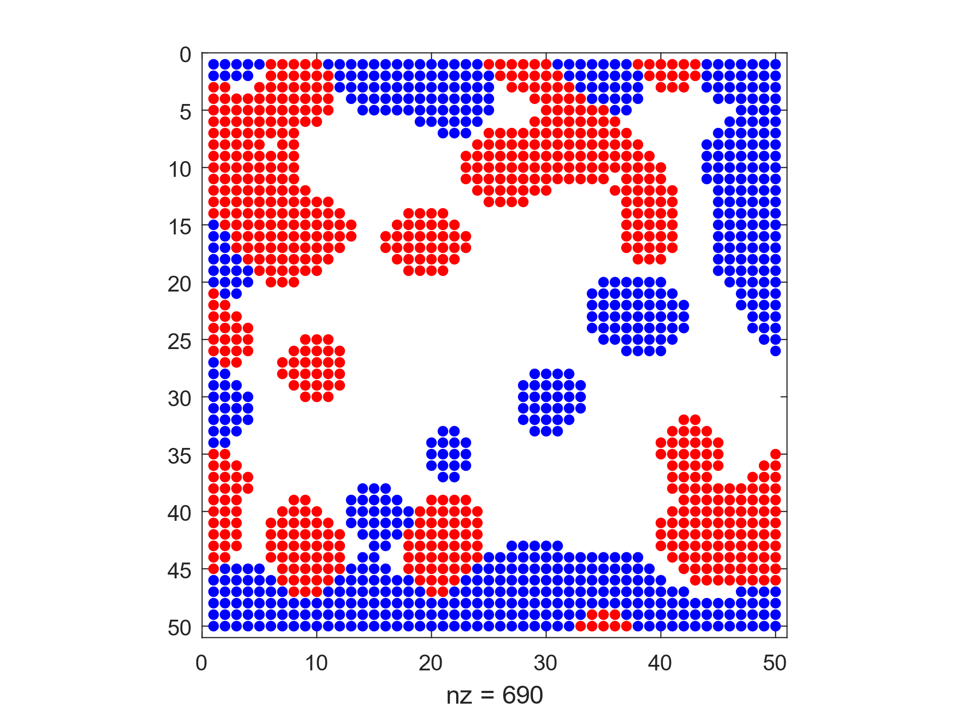

*Figure 13: Empty Ratio = 0.6, Similarity Threshold = 0.4*

This Schelling model converges faster for lower empty ratios as there is less empty space and the agents spend less time looking for similar agents to neighbour. When there is more empty space, the model takes more iterations to converge as the agents have to traverse the empty space to find similar neighbours.

5c)

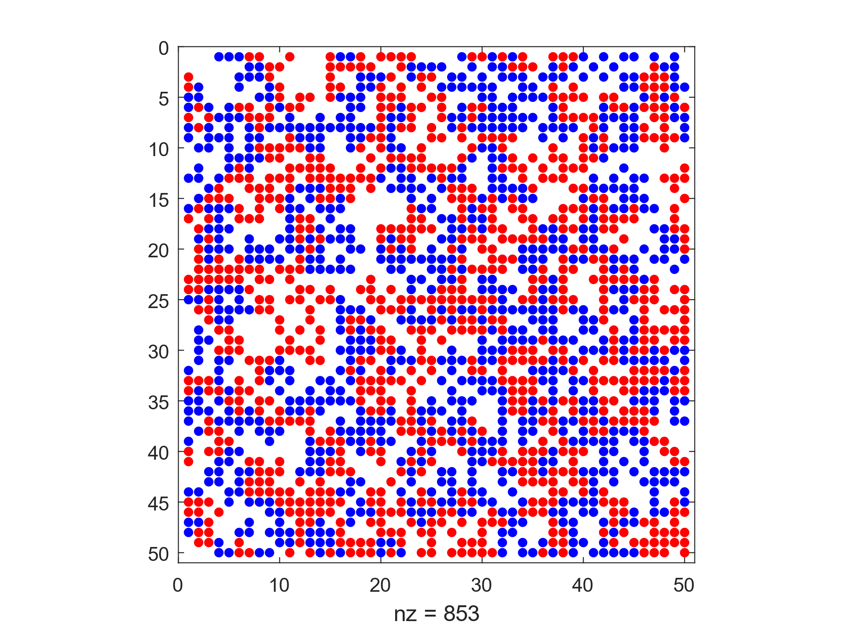

*Figure 14: Empty Ratio = 0.4, Similarity Threshold = 0.2*

Average similarity = 3.3716, Similarity Ratio = 0.4359

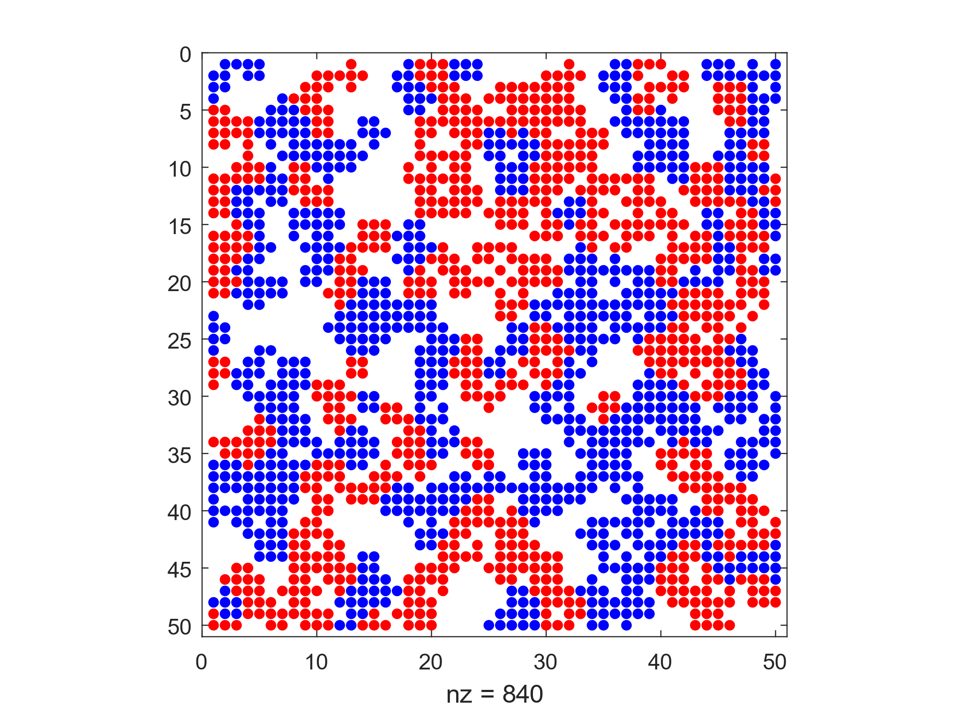

*Figure 15: Empty Ratio = 0.4, Similarity Threshold = 0.3*

Average similarity = 4.7468, Similarity Ratio = 0.6141

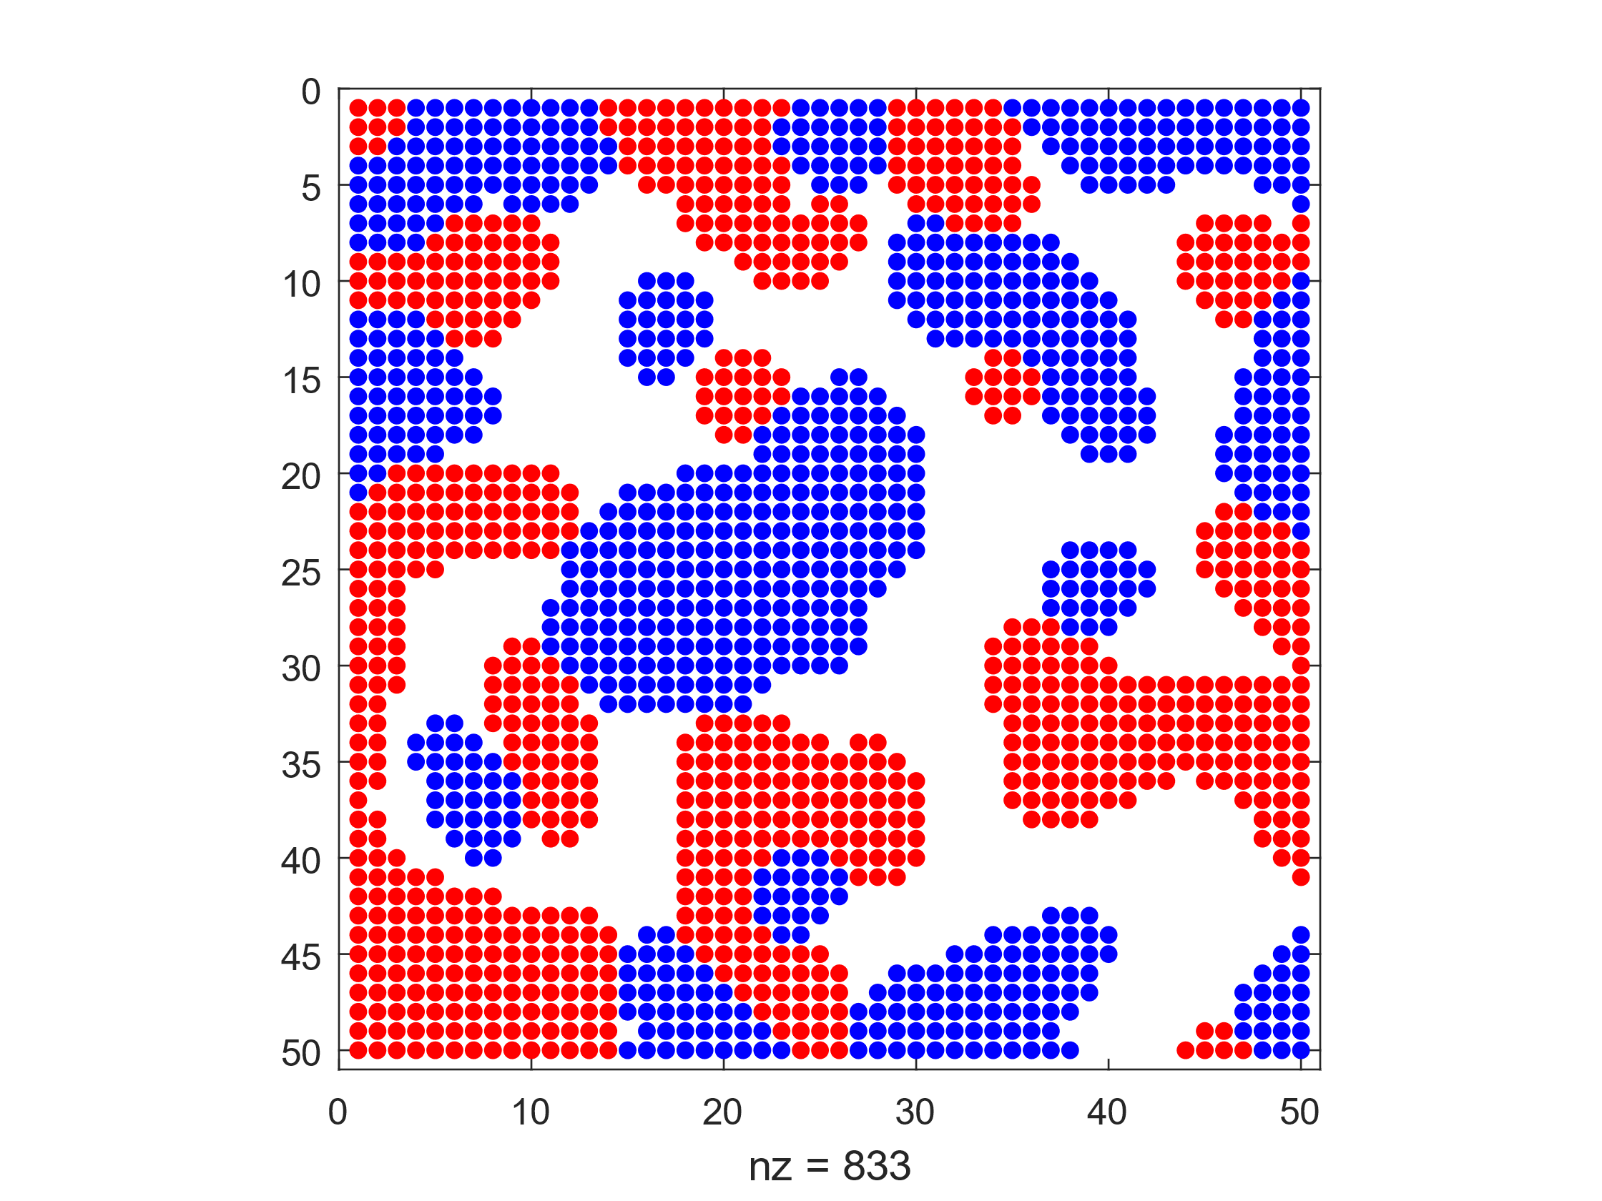

*Figure 16: Empty Ratio = 0.4, Similarity Threshold = 0.4*

Average similarity = 6.4284, Similarity Ratio = 0.8325

For each of these simulations, the Average similarity is the number of surrounding blocks of the same type. A theoretical max of 8 can be achieved for agents not on the edge of the model. For each of these models, the similarity ratio is higher than the similarity threshold and as such, these models have successfully converged.